

|  |
| --- |
|  |
| BLOOD SOURCE  TECHIQ |
| |  |  |  | | --- | --- | --- | | Midterm/Final | Semester and Year | EPICS Design Document | |

Contents

Section 1: Project Identification 3

Resources 3

Project Objective Statement 3

Description of the Community Partner 3

Stakeholders 3

Outcomes/Deliverables 3

User Need List 4

Expected Overall Project Timeline 4

Section 2: Specification Development 5

Resources: 5

Description of the Use Context 5

Benchmarking 5

Specification List 6

Section 3: Conceptual Design 7

Resources: 7

Concept Generation 7

Prototyping 7

Concept Convergence 7

Proposed Solution 7

Section 4: Detailed Design 8

Resources: 8

Summary of Detailed Design Process 8

Bill of Material (B.O.M) 8

Prints/Schematics/Code 8

Manufacturing and Assembly Processes 8

Risk Analysis 9

Verification 9

Validation 10

Section 5: Project Delivery 11

Resources: 11

User/Service Manual 11

Delivery Checklist 11

Customer Satisfaction Questionnaire 11

Section 6: Current Semester Record 12

Appendix A: Past Semester Records 13

*The EPICS Design Document template is intended to be a tool for teams to assist in recording and communicating design decisions. Modifications, insertions, and deletions may be appropriate based the project discipline, scope, or other project-specific factors.*

# Section 1: Project Identification

## Tutorials

* Documentation: [https://tinyurl.com/EpicsDesignProcessDocument](https://tinyurl.com/EPICSDesignProcessDocument)
* Video Tutorial: <https://tinyurl.com/EpicsProjectIdentification>

## Project Objective Statement

• Based on our survey found that blood donation was a bit difficult for uneducated and rural people.

• The reasons for difficulty in blood donation are

• Lack of transportation

• Lack of knowledge

• No proper guidelines

• Time-consuming.

## Description of the Community Partner

• Our community partner is patients in the hospital who need blood.

• This will be very useful for the people who are uneducated as they do not know where to find the blood and whom to approach in an emergency.

• They can take the help of their relatives, friends, or hospital management team in worse conditions.

## Stakeholders

• The stakeholders of this project are normal people, especially patients’ families.

• At the times when the patient cannot be left alone but at the same time need to get blood from the blood banks the family members can easily be benefitted from this project.

• They can easily find the donors in the nearby location and get the blood easily transported.

• The donors play a vital role in the project’s success.

• The social workers are also the stakeholders in this project.

## Project Scope

• The scope clearly defines the boundaries of the proposed system.

• The functional areas of this application that lies under the scope of the proposed system are the management of the availability of donors, hospitals, and blood banks to the user or member at any time.

• One important future scope is the availability of location-based blood bank details and extraction of location-based donor detail, which is very helpful to the acceptant people.

• Quick verification of the patients and the donors.

## User Need List

This section should include a complete list of the major functions needed by each stakeholder:



## Expected Overall Project Timeline

*Project Start Date:* 23/08/2022 *Original Target Delivery Date:*

• TIMELINE FOR COMPLETION OF PROJECT:

o We feel that it might take 6 to 8 months to complete our project.

• ORIGINAL TARGET DATE:

o By the end of the semester.

• TEAMS ASSESSMENT:

o Equal sharing of work among team members might make the project successful in the given timeline.

* + Gantt Chart Template: <https://asq.org/quality-resources/gantt-chart>

# Section 2: Specification Development

## Tutorials

* Documentation: [https://tinyurl.com/EpicsDesignProcessDocument](https://tinyurl.com/EPICSDesignProcessDocument)
* Video Tutorial: <https://tinyurl.com/EpicsSpecificationDevelopment>
* IP Process: <https://www.prf.org/otc/resources/commercialization.html>

## Description of the Use Context

* This project is useful for people who need blood but don’t have an idea like where to get it, how to approach the blood bank etc.
* Our idea will also include the transportation of blood units through social workers or NGOs.
* This will notifies the donors so that they can get the information about the address.
* Through GPS-web cam the location of the hospital is done.
* Even in rural areas our app can be used with the help of management staff.
* We think there will be no misuse of our app.
* The requirements for our project are NGOs and hospital management staff support.
* Our project is assessable to everybody at any point in time (24/7).
* This project will require internet and a GPS cam.
* Weather conditions may affect the internet so there may be a delay in the blood.
* Due to the weather conditions the transportation of the blood may also be delayed.
* There will be details of the donors and health conditions of him/ her for the broader way.

## Benchmarking

This section should include a survey of existing solutions and competing technology.

* Donor2Donor, a visionary approach to help the man kind in saving a life through the effective use of technology. Donor2Donor is a portal devoted to help patients in need of blood transfusion and helps them to find out a compatible blood donor. D2D mobile application can be downloaded from specific app stores supporting this application, D2D helps to match the user in need of blood, through its feature in application called as “Requirement” with the available donor of that specific blood group through its portal. D2D may offer additional services or revise any of the services. All rights to cease offering of any of the services on the sites are reserved with D2D.
* We compare it to the ‘donor2donor’ app. We will modify and provide some new solutions which d2d doesn’t provide.
* Are there any potential barriers to intellectual property?

## Specification List

Specifications are the translation of your User Needs into measurable requirements. To create a list of your project specifications, start by copying your list of user needs. For each user need, list the specifications that you must meet to satisfy that requirement. As you write your specifications, keep in mind you must be able to test the product to ensure that the specification has been met.

|  |  |  |  |
| --- | --- | --- | --- |
| Need # | User Need | Spec # | Specification |
| 1 | *Easily accessible by anyone* |  |  |
|  |  | 1.1 | *Through login and signup everyone can access it.* |
| 2 | *Search for blood should be made easier through the app* |  |  |
|  |  | 2.1 | *People can search for the donor by entering their blood group.* |
|  |  |  |  |
| 3 | *There must be no network issues and be helpful in all ways.* |  |  |
|  |  | 3.1 | *The network is based on the place where they use.* |
|  |  |  |  |
| ... | ... | ... | *...* |

# Section 3: Conceptual Design

## Tutorials

* Documentation: [https://tinyurl.com/EpicsDesignProcessDocument](https://tinyurl.com/EPICSDesignProcessDocument)
* Video Tutorial: <https://tinyurl.com/EpicsConceptualDesign>

## Concept Generation

This section is a place to capture artifacts (pictures, video, drawings, descriptions, etc.) from brainstorming activities. Documenting all of your viable ideas here will provide a place to come back if the solution you choose does not work out. Consider:

* We did the field survey where we got to know about the people’s problems, and we generated this idea.
* We are using android studio for our front end and firebase to store the details in database.
* We can store the details of the users entered through login and signup pages.

## Prototyping

This section should document the early prototypes that the team has created to represent solutions. This process is iterative and may include several rounds of prototyping. Include any artifacts (pictures, videos, etc.) for reference. Consider:

* We are facing issues to connect android to the firebase, but we are working to solve those issues.
* It is intended for the external partners.

As you test these prototypes internally or discuss with partners, record observations.

* We learnt how to use android studio and firebase and develop different apps in it.
* They were excited for all the ideas which we wanted to implement in our app.
* We changed our idea of uploading the prescription through gps scanner and transportation of blood after taking inputs from the user.

## Proposed Solution

This section should include a complete description of the proposed design concept, including sketches, process diagrams, or other artifacts to convey the concept. Consider whether this solution may be patentable. This solution should be approved by the advisor and partner before proceeding to detailed design.

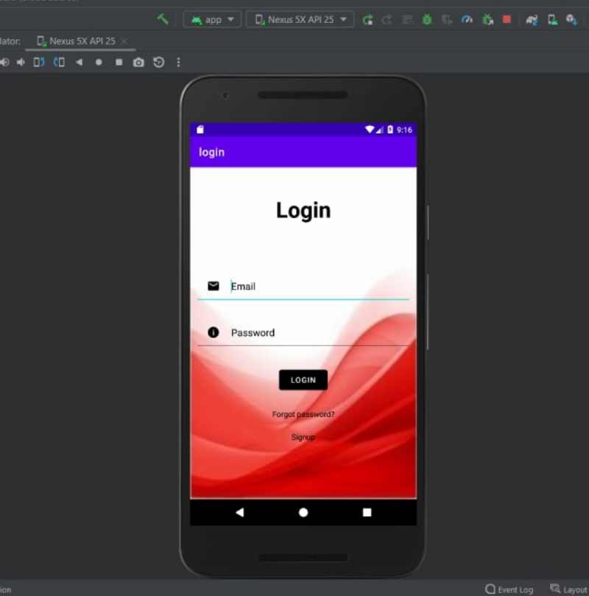

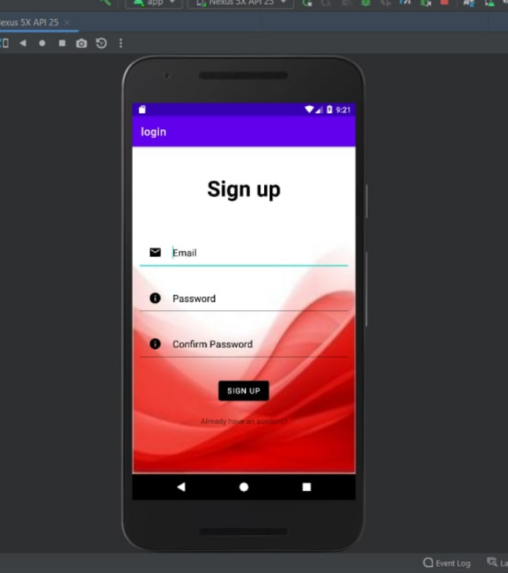

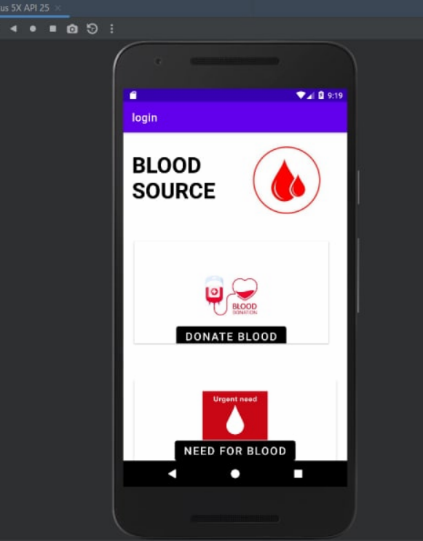

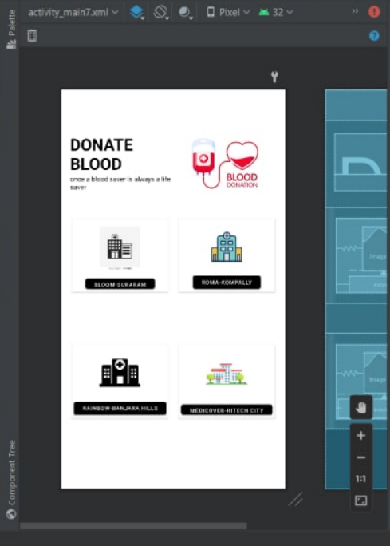

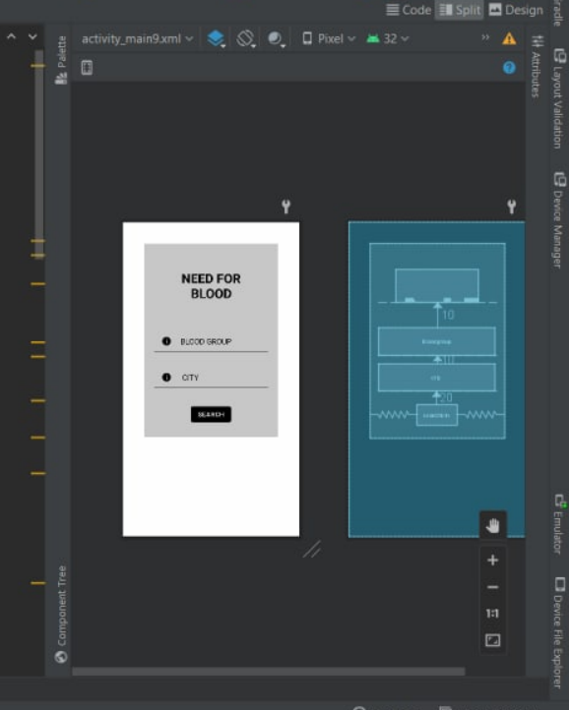

# Section 4: Detailed Design

## References:

* Documentation: [https://tinyurl.com/EpicsDesignProcessDocument](https://tinyurl.com/EPICSDesignProcessDocument)
* Video Tutorial: <https://tinyurl.com/EpicsDetailedDesign>

## Prints/Schematics/Code

This section should provide links to any relevant material that describe the technical details of each component and the overall assembly or technology stack, whether the project is physical, virtual, or both. These materials should be of quality and completeness such that a 3rd party of reasonable skill could fabricate the project without additional instruction.

* https://youtu.be/tc0nFn2Lfk4
* <https://youtu.be/gaykE36N7PY>
* <https://youtu.be/Pr4Jz5Lc5pM>
* <https://youtu.be/xsOUKDChyfc>
* <https://youtu.be/G6f6lm3ZCTU>
* <https://youtu.be/bgIUdb-7Rqo>
* https://youtu.be/0QqAkopW31M

## Risk Analysis

This section should include a link or pasted image of any risk analysis or risk mitigation activities. One of the most common tools for risk analysis is the Failure Mode and Effect Analysis (FMEA).

* FMEA Template: [American Society for Quality FMEA Template](http://asq.org/learn-about-quality/data-collection-analysis-tools/overview/asq-fmea-template.xls)

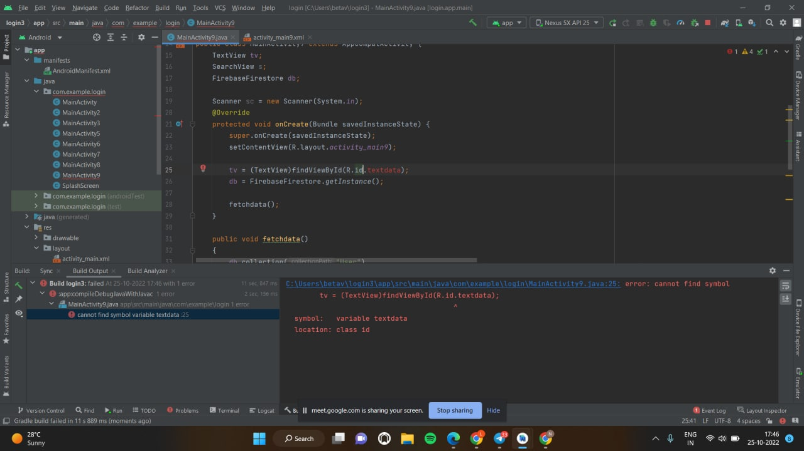

* We are fetching the list of donors and displaying it properly.
* We are facing issues in fetching the data with specific conditions.

## Verification

This section should include a table summarizing the results of verification activities for the project. A link to the verification test report should also be included in the table. Verification is the process of making sure the design outputs meet the design specifications. Each specification should be verified, which can take any form that confirms that the specification is met. Be sure to consider any residual high risks from the assessment.

|  |  |  |
| --- | --- | --- |
| Spec # | Specification | Verification |
|  |  |  |
| 1.1 | *Through login and signup everyone can access it.* | *Login and sign-up pages have successfully stored the details and are working properly.* |
|  |  |  |
| 2.1 | *People can search for the donor by entering their blood group.* | *We can display the details. (Through the code)* |
|  |  |  |
|  |  |  |
| 3.1 | *The network is based on the place where they use.* | *This specification is also satisfied.* |
|  |  |  |
| ... | ... | ... |

## Validation

This section should include a table summarizing the results of validation activities for the project. A link to the validation test report should also be included in the table. Validation is the process of demonstrating that the final design meets the user needs. Each user need should have at least one validation, which can take any form that confirms that the user need is met.

|  |  |  |
| --- | --- | --- |
| Need # | User Need | Validation |
| 1 | *Easily accessible* | *Everyone can access it using login and sign-up pages.* |
| 2 | *Searching should be easier* | *Users can search for the donors of any age by entering the blood group.* |
| 3 | *No network issues* | *Works in any type of network areas.* |

# Section 5: Project Delivery

## TUTORIALS

* Delivery Process:
  + <https://engineering.purdue.edu/EPICS/teams/team-documents/project-delivery>
* Delivery Checklist:
  + <https://engineering.purdue.edu/EPICS/teams/team-documents/delivery-checklist>

Partner agreements mandate the completion of the delivery checklist. Failure to complete the checklist and receive EPICS administrative approval may result in personal liability.

**Do NOT deliver a project until the checklist is completed and approved by both the advisor and EPICS administration.**

## Customer Satisfaction Questionnaire

Should be completed by the community partner two weeks after delivery. Link or copy the completed questionnaire onto this page.

* Customer Satisfaction Questionnaire: <https://tinyurl.com/EpicsCustomerSatisfaction>

## Record of project delivery

Please add or link to a photo and/or video of the project at the time of delivery.

